**PRACTICAL 1**

**AIM: Theory assignment for writing details about LEX and YACC**

**compilation.**

**CODE:**

%{

#include <stdio.h>

%}

%%

one|ONE|One printf("1") ;

two|TWO|Two printf("2") ;

three|THREE|Three printf("3") ;

four|FOUR|Four printf ("4") ;

five|FIVE|Five printf("5");

six|SIX|Six printf("6");

seven|SEVEN|Seven printf("7");

eight|EIGHT|Eight printf("8");

nine|NINE|Nine printf("9");

zero|ZERO|Zero printf("0");

%%

int main()

{

yylex();

return 0;

}

CODE-

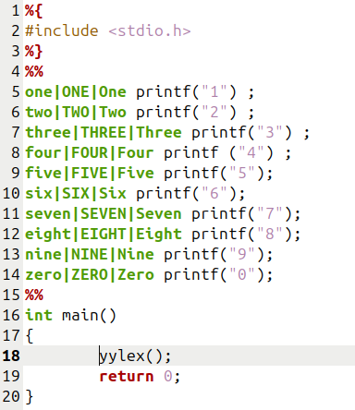

OUTPUT-

